Abstract: The abstract should summarize the contents of the paper and should contain at least 70 and at most 200 words. It should be set in 9-point font size, justified and should have a hanging indent of 2-centimenter. There should be a space before of 12-point and after of 30-point.
ASIAGRAPH 2012 PROCEEDINGS
多媒体(自國語題目)
- 芸術科学- (自國語副題目)
Author Instructions (Title in English)
--- Asiagraph 2012 Proceedings (Subtitle in English)
洪吉童/東京大学 媒体Digital学科, 降順童/東京大学 媒体Digital学科 (自国語＿名前/所属)
First Author Name¹/Department of Digital Design, Asia University, Second Author Name²/Department of Computing, Graph University
*¹f_author@asia.edu, *²s_author@asia.edu
Keywords: The paper should have at least one keyword. This paragraph should be justified with a linespace of exactly 11-point, special indentation of 2-centimeters and with a spacing before of exactly 48-points. The text should be set in 9-point font size and without the use of bold or italic font style.

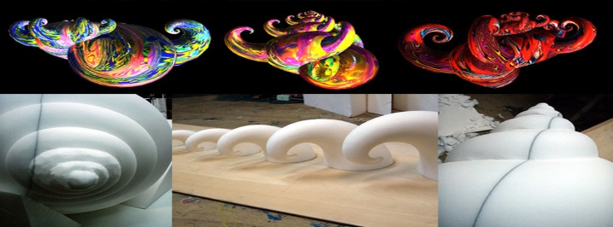
1. Introduction
Figure 1: Colored plates or photographs should be placed on EVERY PAGE.
Your paper will be part of the conference proceedings therefore we ask that authors follow the guidelines explained in this example and in the file "Asiagraph-template11.doc" also on the zip file, in order to achieve the highest quality possible.
Be advised that papers in a technically unsuitable form will be returned for retyping. After returned the manuscript must be appropriately modified.
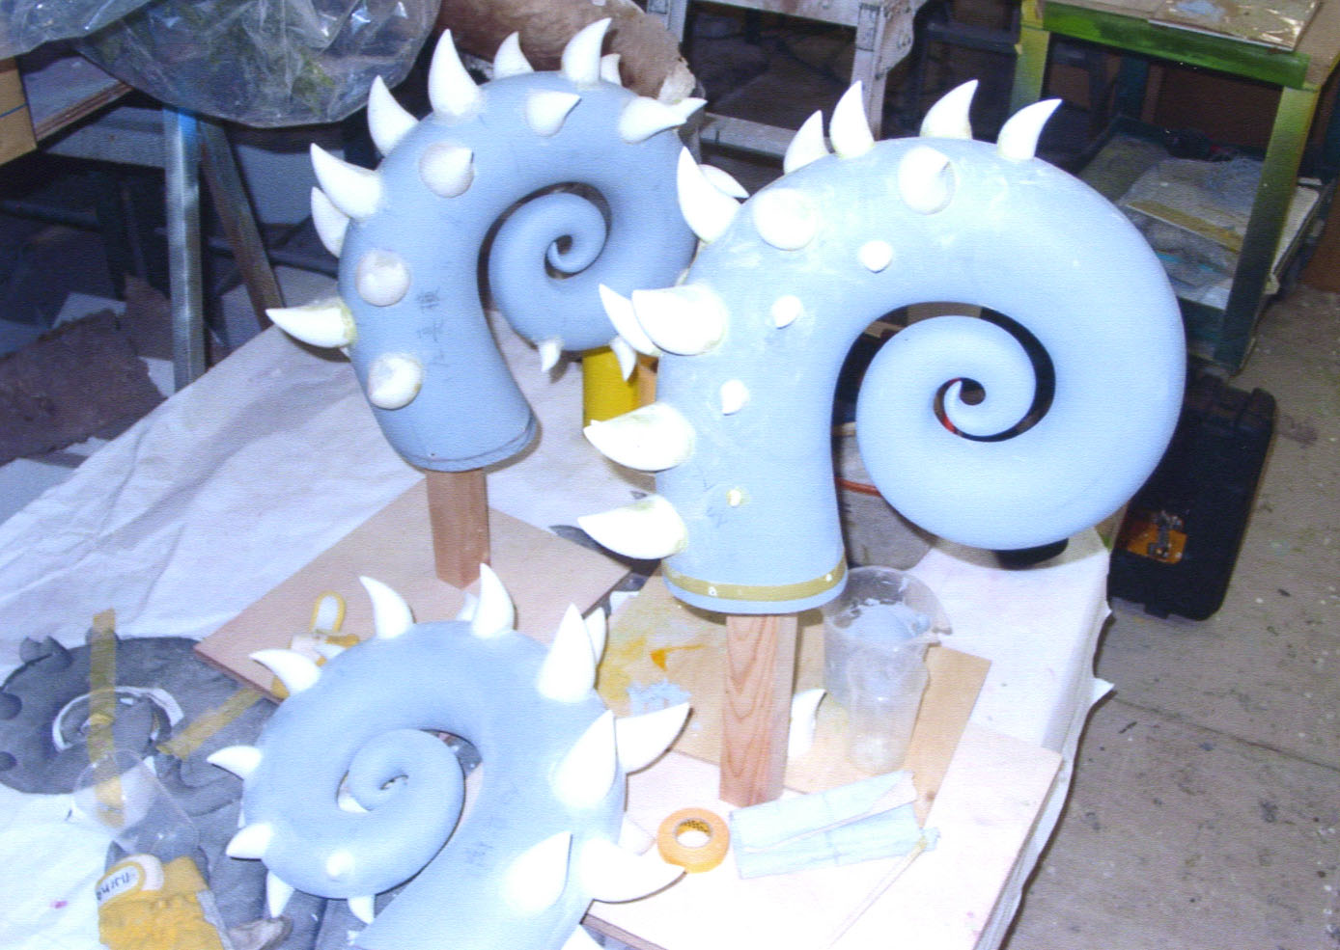
2. Manuscript Preparation
Figure 2: Please consider to include color plates as many as possible.
Please remember that all the papers must be in English and without orthographic errors.
Do not add any text to the headers (do not set running heads) and footers, not even page numbers, because text will be added electronically.
For a best viewing experience the used font should be Times New Roman, on a Macintosh use the font named times, except on special occasions, such as program code (Section 2.3.7).
Please make sure to include colored plates or photographs on EVERY PAGE, hopefully more than 40% of space is devoted to graphics, since the proceedings is printed in full colours throughout the whole volume.
2.1. Page Setup
The paper size should be set to A4 (210 x 297 mm). The document margins should be the following:
- Top: 2.5 cm;
- Bottom: 2.0 cm;
- Left: 1.5 cm;
- Right: 1.5 cm.

It is advisable to keep all the given values.
Regarding the page layout, authors should set the Section Start to Continuous with the vertical alignment to the top and the following header and footer:
- Header: 1.5 cm;
- Footer: 1.75 cm.
Any text or material outside the aforementioned margins will not be printed.
2.2. First Section
This section must be in one column.
2.2.1. Title & Subtitle
Title in own language : Ms Ghothic, 14-point
Subtitle in own language : Ms Ghothic, 12-point
Title in English : Times New Roman 13-point
Subtitle in English : Times New Roman 11-point

2.2.2. Authors
Name/Affiliations in own language : MS Mincho 8-point
Name/ Affiliations in English : : Times New Roman 8-point

2.2.3. Keywords
Each paper must have at least one keyword. Keywords should appear justified, with a linespace exactly of 11-point, a hanging indent of 2-centimeters, spacing before of 48-point, no spacing after and font size of 9-point.
The sentence should end with a period.
2.2.4. Abstract
Each paper must have an abstract. The abstract should appear justified, with a linespace exactly of 11-point, a hanging indent of 2-centimeters, spacing before of 12-point and after of 30-point, and font size of 9-point.
The sentence should end with a period.
3. Second Section
This section must be in two columns.
Each column should be in 7.5-centimeter width with a column spacing of 0.8-centimeter.
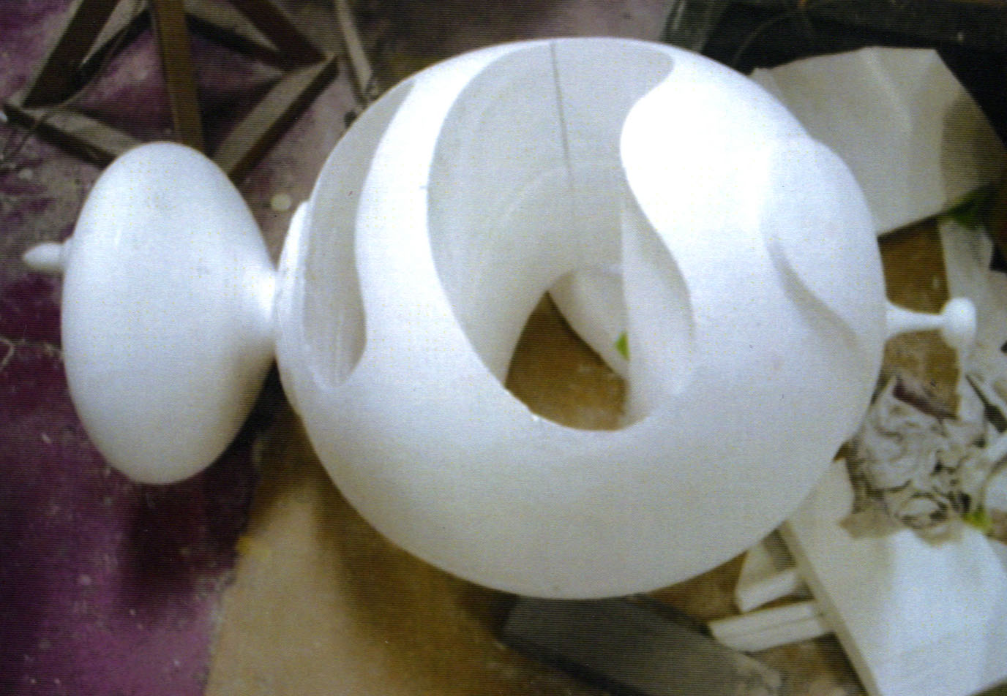
The section text should be set to 10-point, justified and linespace single.
Section, subsection and sub subsection first paragraph should not have first line indent, other paragraphs should have a first line indent of 0.5-centimeter.
3.1. Section Title
The heading of a section title should be in 12-point bold with initial letters capitalized, aligned to the left with a linespace exactly at 15-point, additional spacing of 26-point before (not applicable to the first title section of the paper) and 13-point after.
3.2. Subsection Titles
Figure 3: Please consider to include color plates as many as possible.
The heading of a subsection title should be in 11-point bold with initial letters capitalized, aligned to the left with a linespace exactly at 13-point, additional spacing of 11-point before (not applicable right after a section title) and 11-point after.
3.3. Sub Subsection Titles
The heading of a sub subsection title should be in 11-point bold with initial letters capitalized, aligned to the left with a linespace exactly at 12-point, additional spacing of 10-point before (not applicable right after a subsection title) and 10-point after.
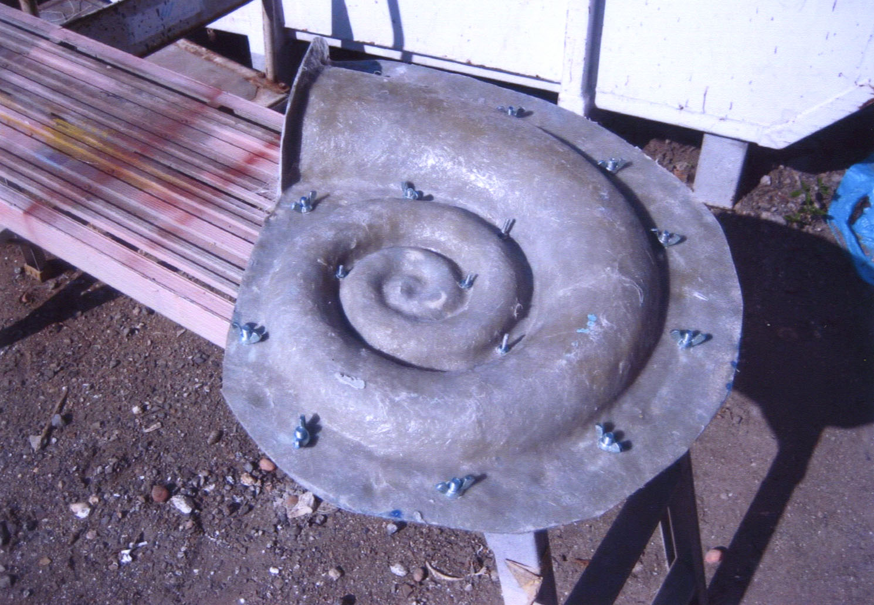
3.4. Tables
Figure 4: Please consider to include color plates as many as possible.
Tables should be properly numbered, centered and should always have a caption positioned above it. Captions with one line should be centered and if it has more than one line should be set to justified. The font size to use is 9-point. No bold or italic font style should be used. Spacing before and after should be of 12-point and 6-point, respectively.
The final sentence of a caption should end with a period.

Table 1: This caption has one line so it is centered.
Example column 1 | Example column 2
Example text 1 | Example text 2

Please note that the word “Table” is spelled out.

3.5. Figures
Please produce your figures electronically, and integrate them into your document. They must be clearly readable and may not be written one on top of the other.
Figure resolution should be at least 300 dpi.
Figures should be properly numbered, centered and should always have a caption positioned under it. Captions with one line should be centered and if it has more than one line should be set to justified. The font size to use is 9-point. No bold or italic font style should be used. Spacing before and after should be of 6-point and 12-point, respectively.
The final sentence of a caption should end with a period. Please note that the word “Figure” is spelled out.

3.6. Program Code
Program listing or program commands in text should be set in typewriter form such as Courier New.
Example of a Computer Program in Pascal:

//--- Samplers
sampler1D fresnel = sampler_state
{
Texture = <FresnelMap>;
AddressV = CLAMP;
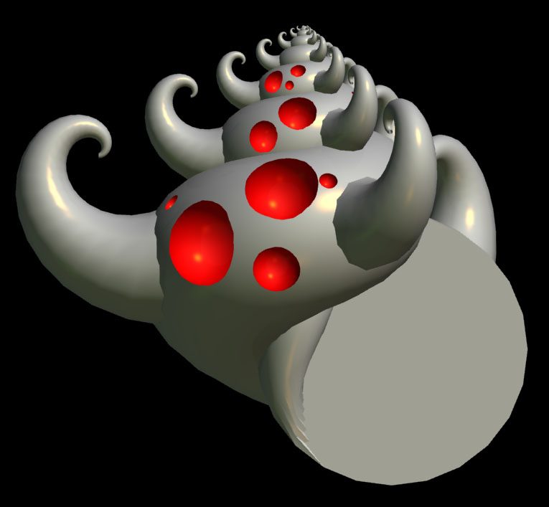
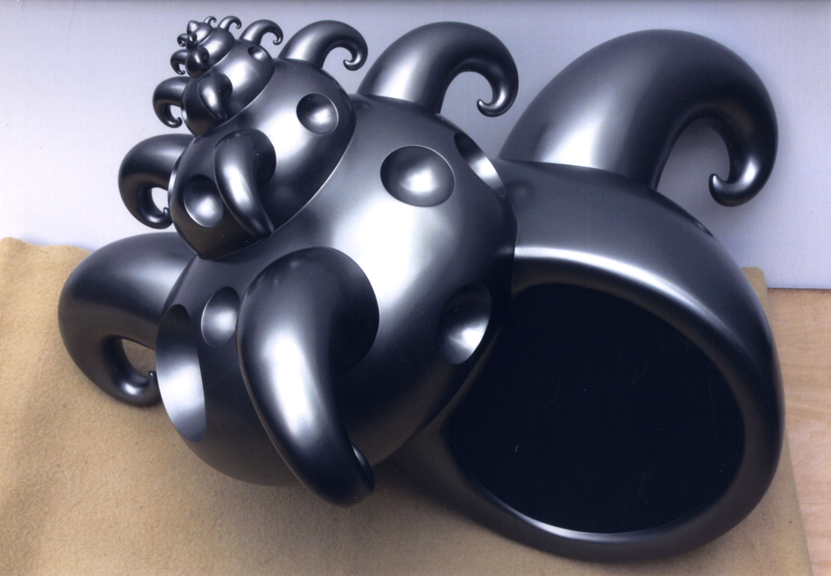
};
Figure 6: This caption has one line so it is centered.
Figure 5: This caption has one line so it is centered.

The text should be aligned to the left with the linespace set to single and in 9-point type.
3.7. Reference Text and Citations
References should be set to 9-point, justified, with a single linespace [Moore99, Smith98] and hanging indent of 0.5-centimenter.
4. Conclusions
Hope you find the information in this template useful in the preparation of your submission.
References
Moore, R., Lopes, J., 1999. Paper templates. In TEMPLATE’06, 1st International Conference on Template Production. INSTICC Press.
Smith, J., 1998. The book, The publishing company. London, 2nd edition.

